Félix Vannier & Catherine Fillion

Mariage : 10 février 1851, St-Jean Baptiste, L’Orignal co.Prescott, Ont.

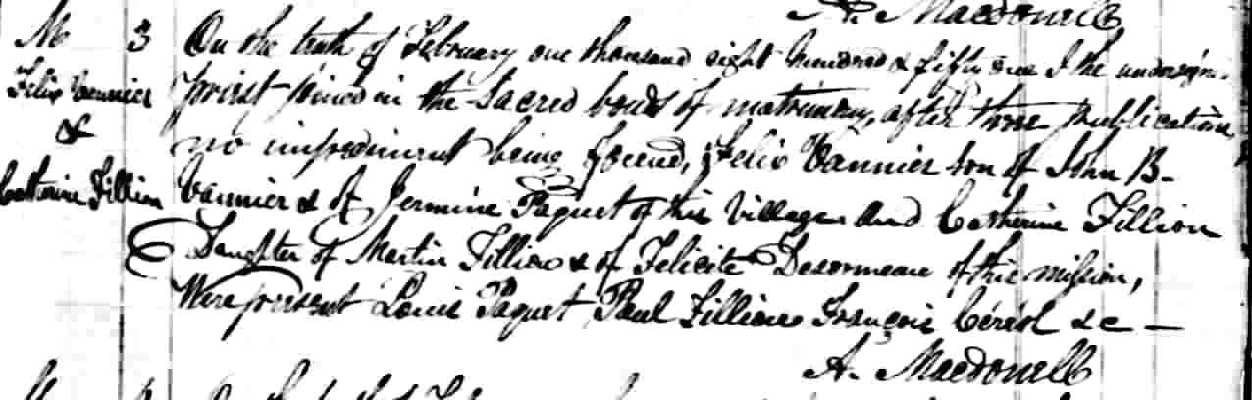

M-3 On the tenth of february, one thousand eigh hundred of fifty one, I the un-
dersigned priest joind in the Sacred bond of matrimony after these publication,
no impediment being found Félix Vannier son of John B. Vannier and Hermine
Paquet of this village and Catherine Fillion daughter of Martin Fillion and of
Félicité Désormeau of this mission. Here présent Louis Paquet, Paul Fillion,
Francois Céréol,
A.Macdonell

Référence : Drouin

